**HVAC MODEL DESIGNER**

A PROGRAM TO ASSIST IN HVAC DESIGNING

Table of Contents

1. Introduction…………………………………………………………………………………….…. pg. 1
2. Modes
   1. Wall Editor
      1. Create…………….………………………………………………………….…….pg. 2
      2. Edit Point………….………………………………………………………….…..pg. 3
      3. Edit Corner/Wall…………………………………………………………..…..pg. 4
      4. Delete Wall……………………………………………………………………….pg. 6
   2. Room Editor
   3. View
      1. Drag 2D…………………………………………………………………...……… pg. 8
      2. Rotate 2D…..……………………………………………………………….…… pg. 3
      3. View 3D…..………………………………………………………………….…… pg. 4
   4. Simulator
3. Floor Picker……………………………………………………………………………….. pg. 7
4. Zoom…………………………………………………………………………………………. pg. 8

**INTRODUCTION**

Are you thinking about designing your own HVAC system to better heat and cool your home or business? Do you want to avoid paying a contractor hundreds (if not thousands) of dollars? Then this software is for you! Allow us to introduce the HVAC Model Designer, a program that will allow you to draw your building, input some data, and obtain an accurate estimation for where heating and cooling units should be installed.

**Purpose and Scope**

This manual is intended to instruct in the use of the HVAC Model Designer software program created by Matthew French, Austin Elliott, and AJ Massey. It is not intended to be used with any other software designed. Ever.

**Organization**

This manual will be divided into sections that detail how each function works. Within each function, there may be sub-functions that will be explained. All functions will include illustrations to better assist those that just like to see pictures instead of reading the manual.

**Point of Contact**

If you have any questions, comments, or concerns about this software, please contact Nathan Bean by bombarding him with emails at: [nhbean@ksu.edu](mailto:nhbean@ksu.edu) or by calling his office several times at: (785) 532-7768 or by stalking his office at: 2216 Engineering Hall.

**MODES: WALL EDITOR - Create**

In the **HVAC Model Designer**, you will be able to create floor plans for every floor in your building. To better assist in doing that, the **HVAC Model Designer** allows the user to create wall structures that store data about windows and doors. The **HVAC Model Designer** starts in **Wall Editor Mode** by default. From here, you can create walls by clicking **Wall Editor -> Create Wall** in the application menu.  
  
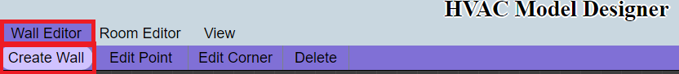  
  
 Once you have done that, you will be able to begin drawing lines on the canvas provided below. These lines will, as you draw, show you the both the perpendicular guideline and the collinear guidelinefor that line. In addition, if you have other lines drawn, you will see the perpendicular and collinear guidelines for the nearest point to the line you are currently drawing.  
  
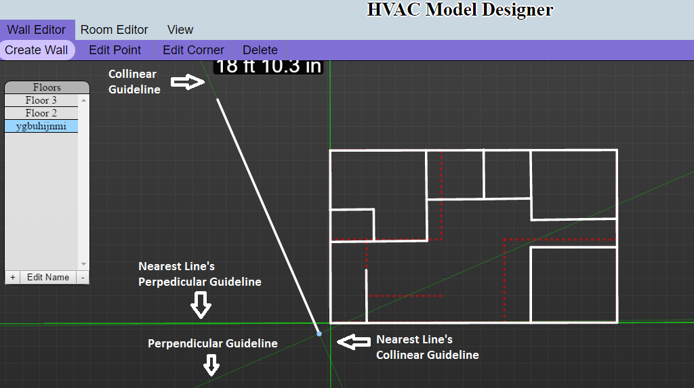

**MODES: WALL EDITOR – Edit Point**

After you have created some walls, you can edit where the endpoints of those walls are located. By clicking **Wall Editor -> Edit Point**.

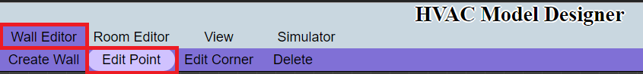

To edit a point, find the point you wish to edit. Then click and move the point to where you wish it to be.  
  
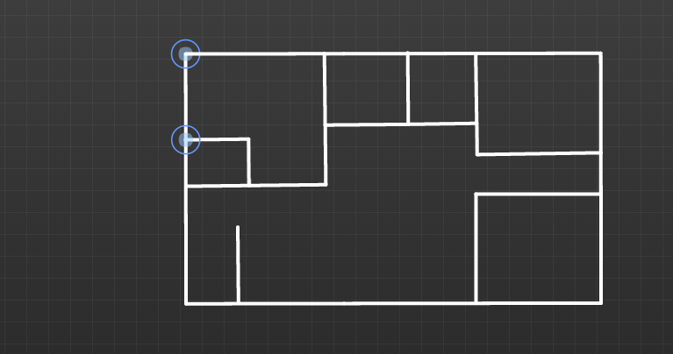

After moving the point to the left:

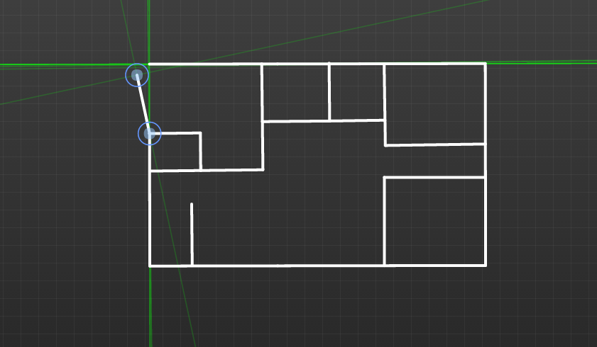

**MODES: WALL EDITOR – Edit Corner**

There is a second way of editing where the endpoints of walls are. This is more specifically for moving corners or entire wall segments. You start by clicking **Wall Editor -> Edit Corner**.



To edit a point, find the point you wish to edit. Then click and move the point to where you wish it to be. For the example below, we will move the middle point.  
  
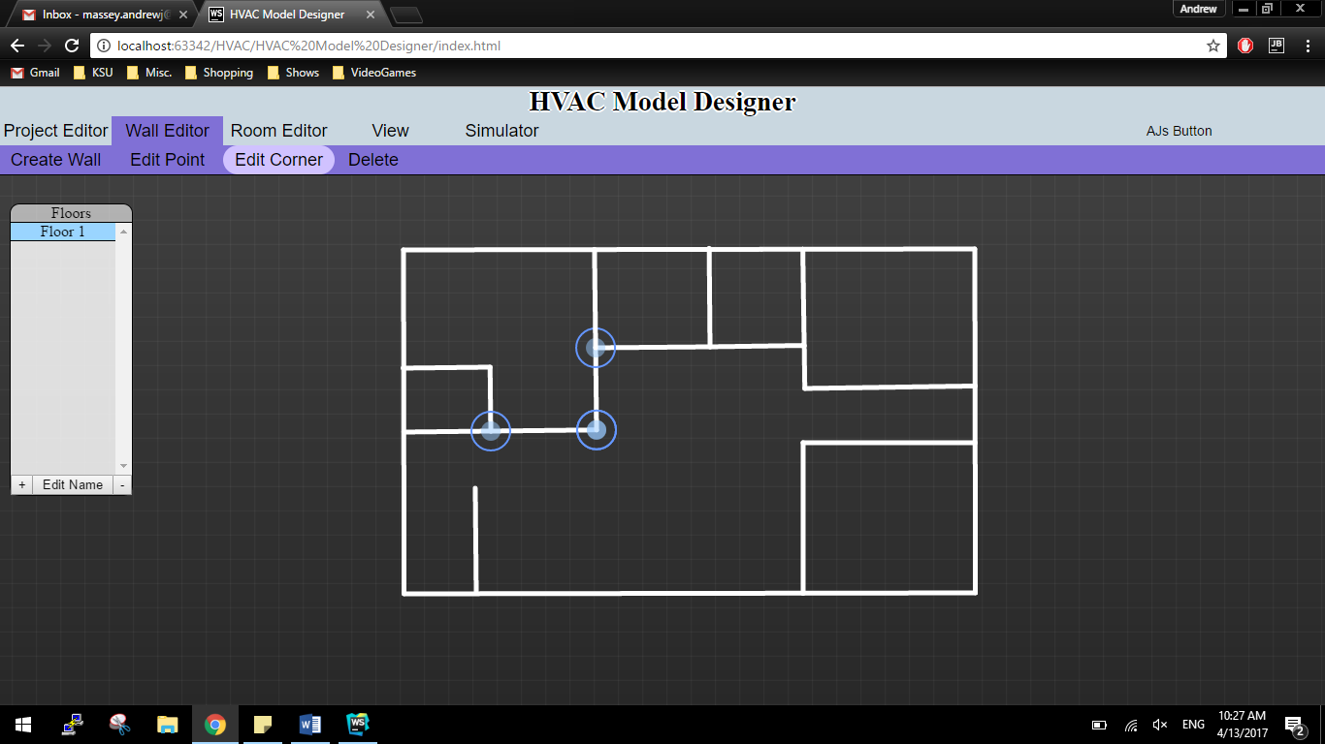

After moving the middle point down and to the right we see that the two walls attached to that corner have elongated to insure that the walls stay attached to the corner that was moved.

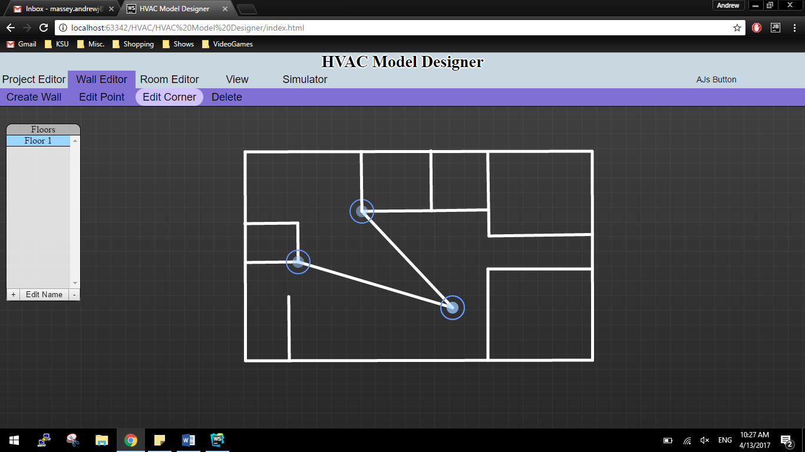

The other action that can be taken with the **Edit Corner** function is that you can completely move sections of walls. In the example below, we choose the lower of the elongated walls and detach it from the other walls:  
  
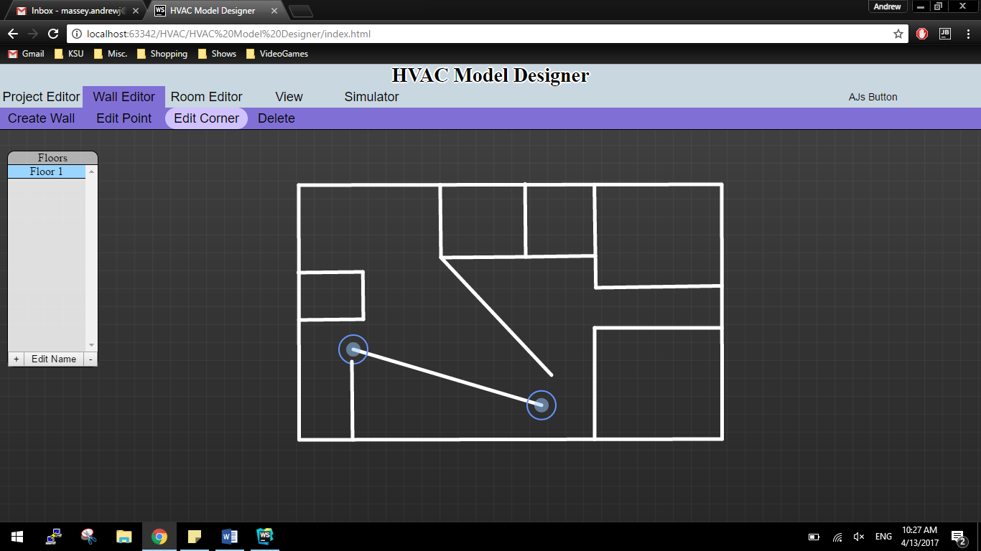

**MODES: VIEW – Drag 2D**

To use the **Drag** function, you will click **View -> Drag 2D**. The **Drag** option will allow you to drag the canvas behind the created structures, enabling you to see different sections of the structure.

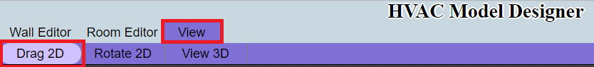

To drag the canvas, click anywhere on the canvas and then slide your mouse in the opposite direction you wish to move.

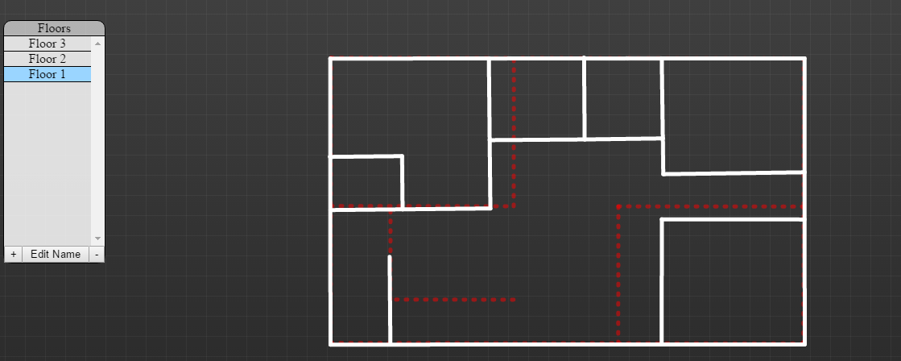

After clicking and moving the mouse to the left:

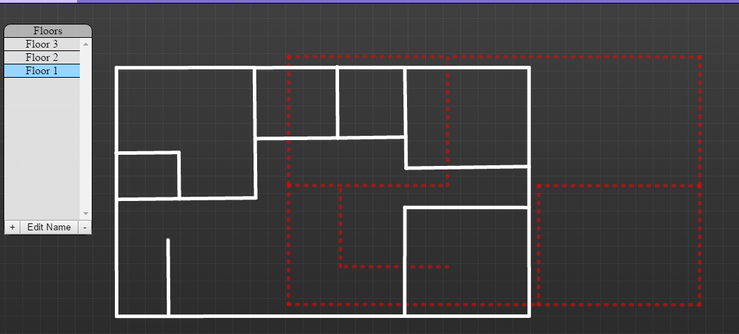

**MODES: VIEW – Rotate 2D**

To use the **Rotate 2D** function, you will click **View -> Rotate 2D**. The **Rotate 2D** option will allow you to rotate the structure, enabling you to see the structure from different angles.

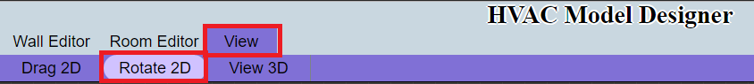

To rotate the structure, click anywhere on the canvas and then move your mouse in the direction you wish to rotate the structure.

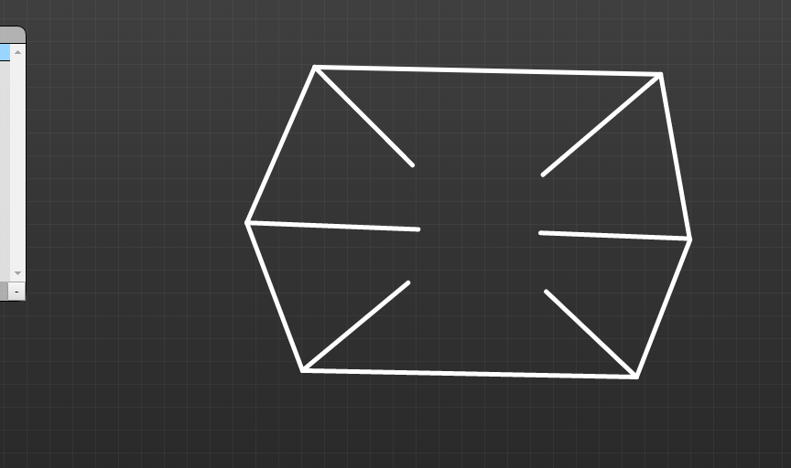

After clicking and moving the mouse to the right:

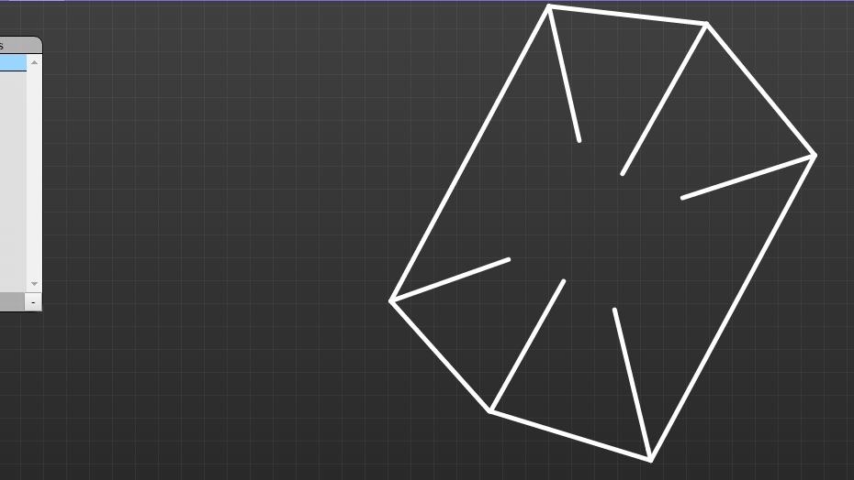

**MODES: VIEW – View 3D**

To use the **View 3D** function, you will click **View -> View 3D**. The **View 3D** option will build 3D objects on top of the structure you have created, enabling you to see the structure from a 3D perspective.

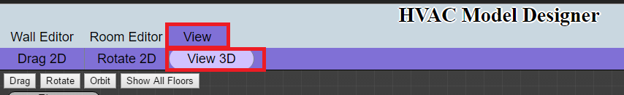

Once in **3D Mode**, more options will be made available to you. The first is the **3D Drag** option.

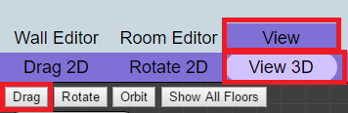

**3D Mode** starts off in the **3D Drag** option, but you can also select this option by clicking **View -> 3D -> Drag**. When **3D Drag** is selected, you will be able to move the structure by clicking anywhere on the canvas and moving the mouse in the direction you want to move the structure.

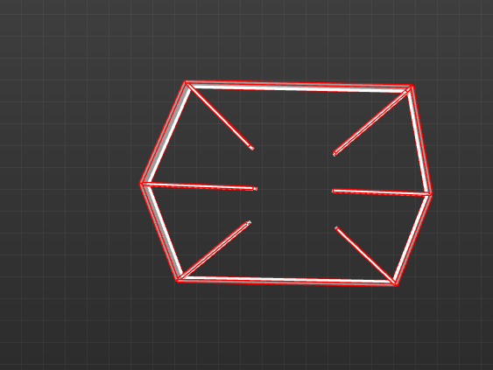

After clicking and moving the mouse to the left:

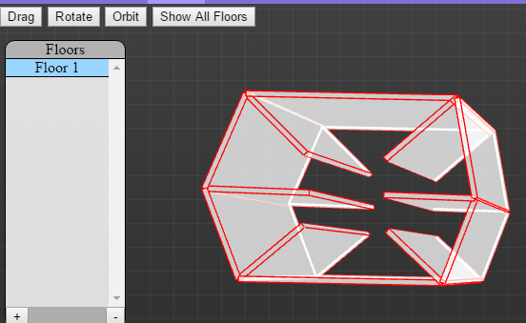

The next 3D option is Rotate. This option will allow you to rotate the 3D structure to see the structure from different angles. To use the **3D Rotate** option, click **View -> View 3D -> Rotate**.

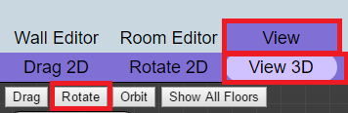

When **3D Rotate** is selected, you will be able to click anywhere on the canvas and rotate the 3D structure in the direction you move your mouse.



After clicking on the canvas and moving the mouse to the left:

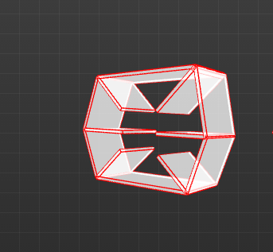

The next 3D option is Orbit. This option will allow you to orbit the 3D structure on one axis. To use the **3D Orbit** option, click **View -> View 3D -> Orbit**.

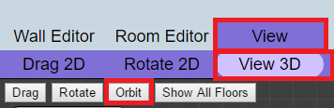

When **3D Orbit** is selected, you will be able to click anywhere on the canvas and move your mouse left and right to see the image orbit on a single plane.

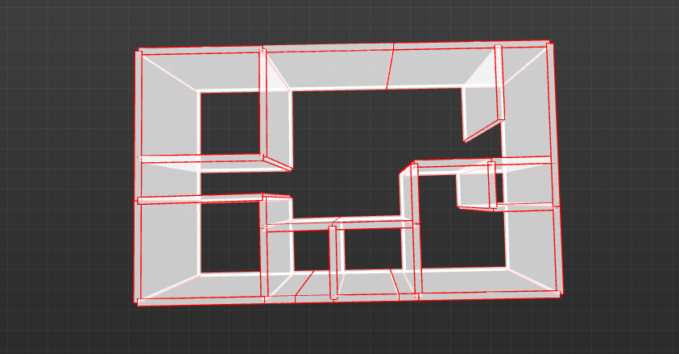

After clicking on the canvas and moving the mouse to the left:

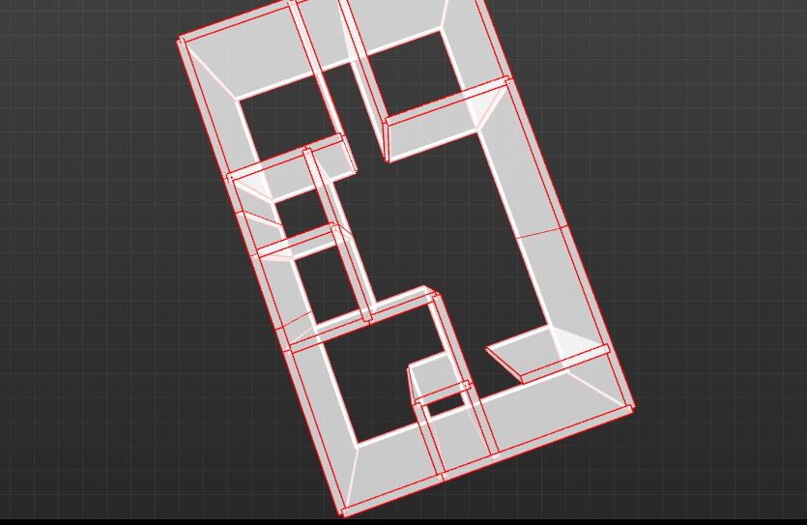

The last 3D option is **Show All Floors**. This option will build all floor plans using 3D objects to show the entire building. To use the **Show All Floors** option, click **View -> View 3D -> Show All Floors**.

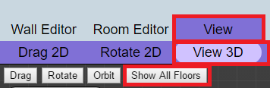

You will know that you are viewing all floors when your canvas shows an image like the one below:

